PHÒNG GD-ĐT QUẬN ĐỐNG ĐA  TRƯỜNG THCS HUY VĂN | NỘI DUNG ÔN TẬP - MÔN TIẾNG ANH 8  (Thời gian nghỉ dịch covid-19 từ ngày 20/4 đến 25/4)

A. KNOWLEDGE
- VOCABULARY
Word | Type | Pronunciation | Meaning
accommodation | (n) | /əˌkɒməˈdeɪʃn/ | chỗ ở
bury | (v) | /ˈberi/ | chôn vùi, vùi lấp
collapse | (v) | /kəˈlæps/ | đổ, sập, sụp, đổ sập
damage | (n) | /ˈdæmɪdʒ/ | sự thiệt hại, sự hư hại
disaster | (n) | /dɪˈzɑːstə(r)/ | tai họa, thảm họa
drought | (n) | /draʊt/ | hạn hán
earthquake | (n) | /ˈɜːθkweɪk/ | trận động đất
erupt | (v) | /ɪˈrʌpt/ | phun (núi lửa)
eruption | (n) | /ɪˈrʌpʃn/ | sự phun (núi lửa)
evacuate | (v) | /ɪˈvækjueɪt/ | sơ tán
forest fire | (n) | /ˈfɒrɪst ˈfaɪə(r)/ | cháy rừng
homeless | (adj) | /ˈhəʊmləs/ | không có nhà cửa, vô gia cư
mudslide | (n) | /ˈmʌdslaɪd/ | lũ bùn
put out | (v) | /pʊt ʌp/ | dập tắt (lửa..)
rage | (v) | /reɪdʒ/ | diễn ra ác liệt, hung dữ
rescue worker | (n) | /ˈreskjuː ˈwɜːkə(r)/ | nhân viên cứu hộ
scatter | (v) | /ˈskætə(r)/ | tung, rải, rắc
shake | (v) | /ʃeɪk/ | rung, lắc, làm rung
tornado | (n) | /tɔːˈneɪdəʊ/ | lốc xoáy
trap | (v) | /træp/ | làm cho mắc kẹt
tsunami | (n) | /tsuːˈnɑːmi/ | sóng thần
typhoon | (n) | /taɪˈfuːn/ | bão nhiệt đới
victim | (n) | /ˈvɪktɪm/ | nạn nhân
- PHONETICS
Stress in words ending in -logy and –graphy

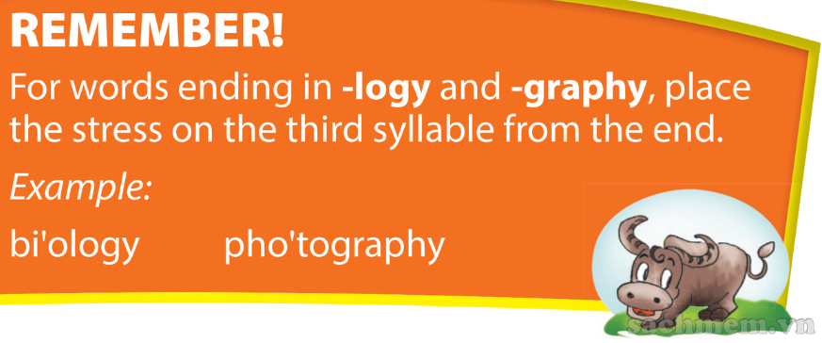
B. PRACTICE
I. Choose the word in each line that has different stress pattern.

1. A. ecology | B. environment | C. residential | D. autography
2. A. physiography | B. criminology | C. unsuccessfully | D. alternatively
3. A. temporary | B. geology | C. logography | D. emergency
4. A. unnatural | B. demography | C. astrology | D. medication
5. A. nationalize | B. television | C. apology | D. voluntary
II. Complete the words under the pictures with -logy or -graphy, then mark the stress syllable in each word. Say the words aloud.
1. bio_________ | 2.video________ | 3.archaeo_____ | 4.tele_______ | 5. zoo________
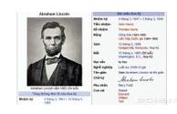
6. bio_____________ | 7. techno_______ | 8. geo________ | 9. psycho____ | 10. photo_____

III. Match the natural disasters with the pictures.

drought lightning earthquake tornado flood
tsunami forest fire typhoon landslide volcanic eruption

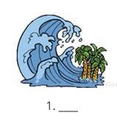 | 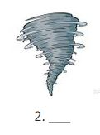 | 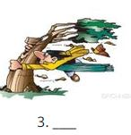 | 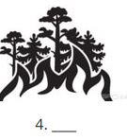
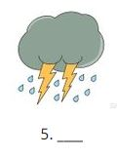 | 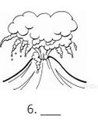 | 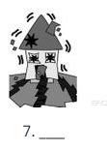
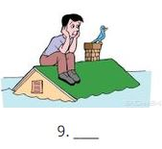 | 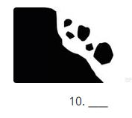

IV. Complete the sentences with the words in the boxes.
avalanche evacuation blizzard explosion disaster
flood drought lightning eruption tsunami

1. The soldiers have been deployed to help avert a looming environmental ____________________ in central provinces.
2. When I was outside in the __________________________, I couldn't see more than a few feet in front of me because of all the snow.
3. Mum went shopping yesterday afternoon and she was very frightened. In the car park, there was an __________________________ and nobody knew what it was.
4. I saw on TV that yesterday there was an ____________________________ on an island in the Pacific and hot lava came down the volcano.
5. My little sister is afraid of __________________, so when there is a bad storm she always hides.
6. Last Sunday we wanted to go skiing, but we couldn't because in the mountains there was an __________________________.
7. A powerful earthquake off the coast of Indonesia sparked a three-metre-high _______________________ killed at least 113 people.
8. If there is a bad ____ in a town, the people have to travel by boat!
9. After the harshest winter in decades, the western region is now facing its hottest summer and the worst ___________________________ across the area in nearly 40 years.
10. People should become familiar with the guidelines for ____________________________ because natural disasters can force them to leave their homes.

----------The end---------

TỔ TRƯỞNG  (kí và ghi rõ họ tên)  Phạm Lan Phương | NHÓM TRƯỞNG  (kí và ghi rõ họ tên)  Bùi Thị Thùy Dương

